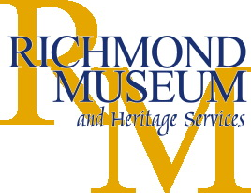
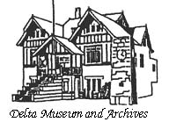
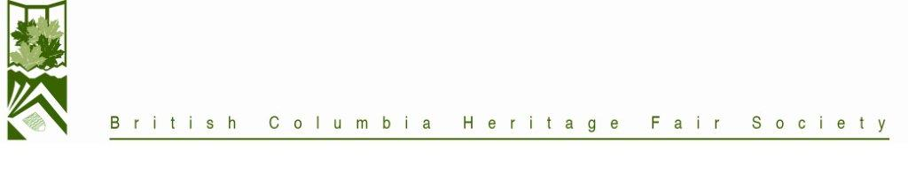
RICHMOND DELTA REGIONAL HERITAGE FAIR
April 30th – May 2nd, 2010
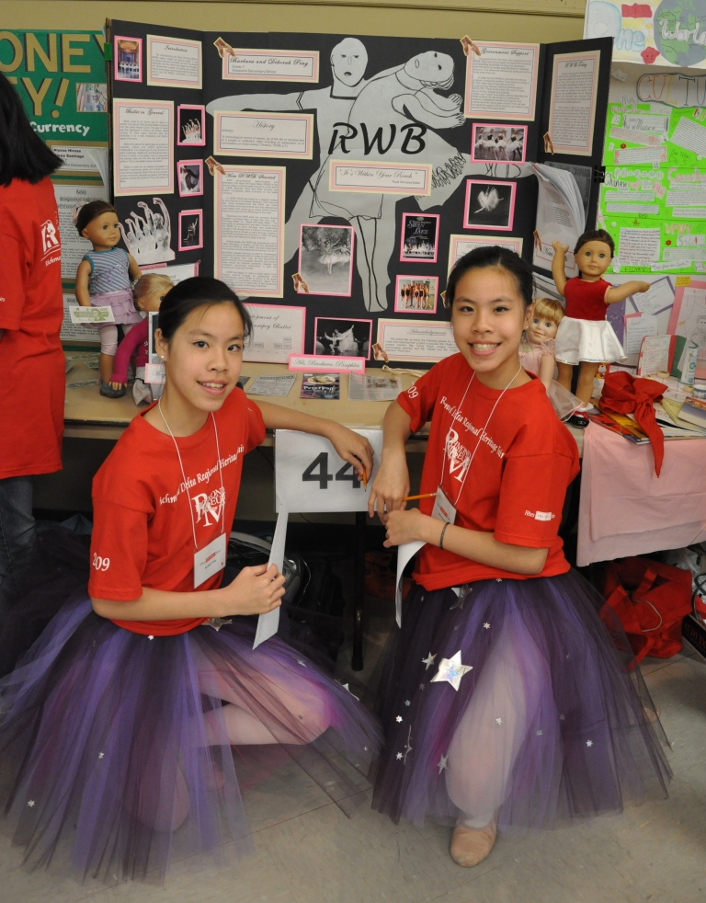
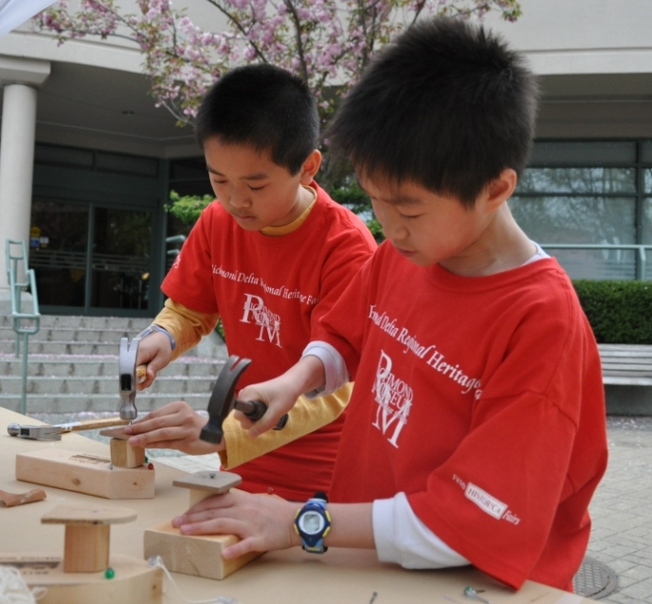
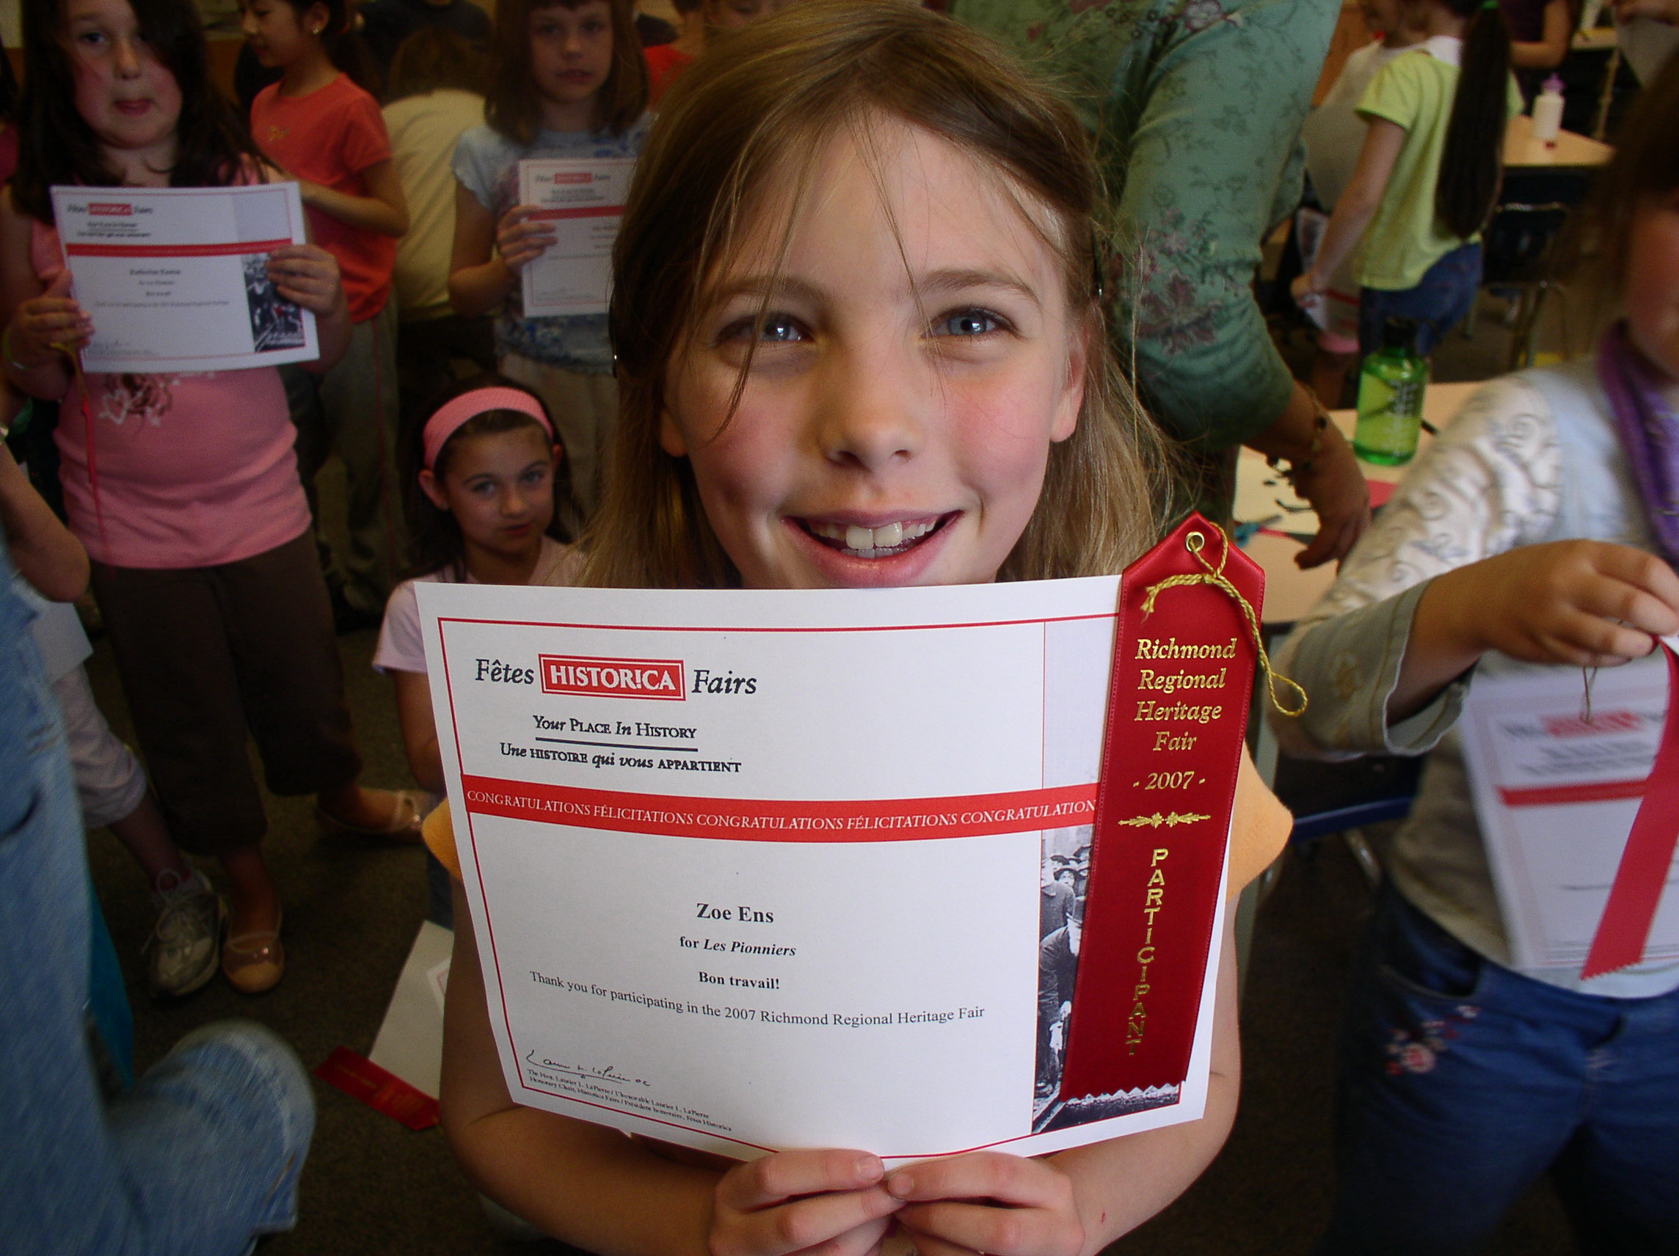

What is it?

Our Fair is entering its eighth year as part of the BC Heritage Fairs Program, which encourages students to explore Canadian history & heritage in a dynamic, hands-on learning environment.

What do students do?

Students use the medium of their choice to share stories about Canadian heroes, legends, milestones, and achievements – and present the results of their research first at a Class/School Fair and then for a selected few, the Regional Fair.

What happens at the Regional Heritage Fair?

On Student Fair Day, student participants present their projects to the public, are interviewed by a select panel of prominent community members, and take part in unique heritage field trips, activities and performances. On Public Fair Days, families and friends are invited to join in on the fun!
Grades K-12, ESL & French Immersion welcome!
Why participate?

- enhances LITERACY SKILLS with an emphasis on communication skills
- supports CROSS-CURRICULAR IRPs with rubrics designed in accordance with the Ministry of Education’s assessment standards
- encourages ACTIVE CITIZENSHIP by celebrating cultural diversity and multiple perspectives that reveal connections between self & community
Contact: Emily So, Richmond Coordinator Carol Ballard, Delta Coordinator
604.247.8334 604.946.9315
museumed@richmond.ca cballard@deltamuseum.ca

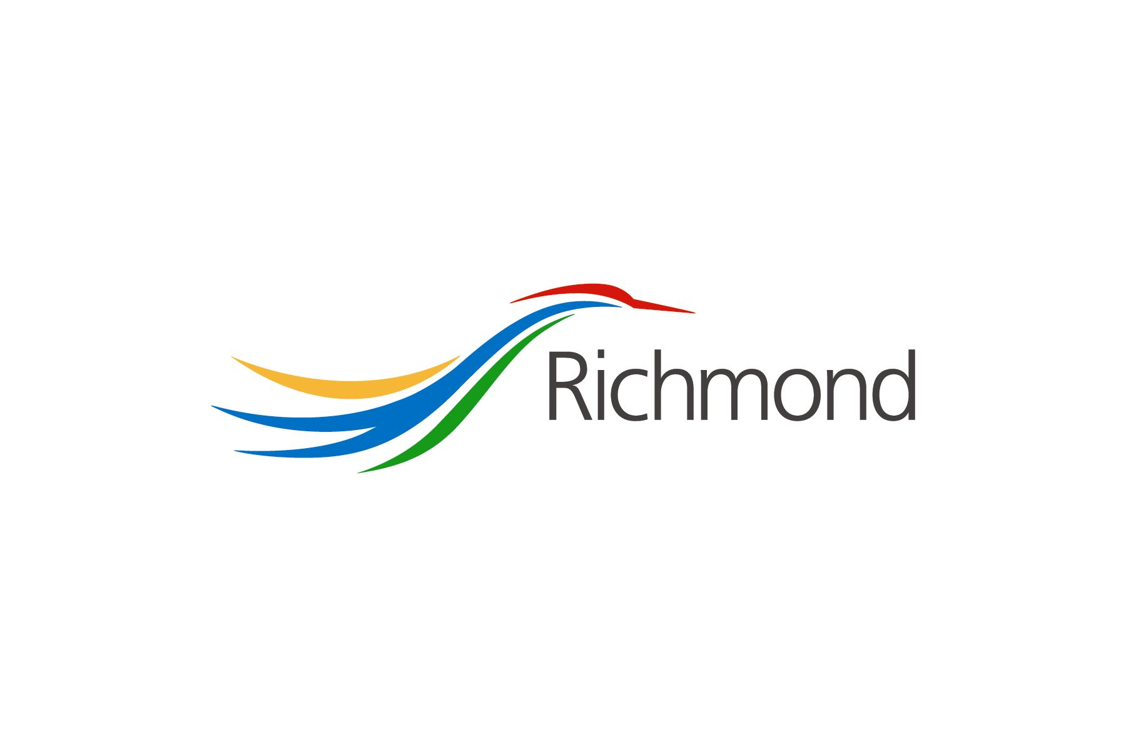
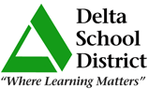
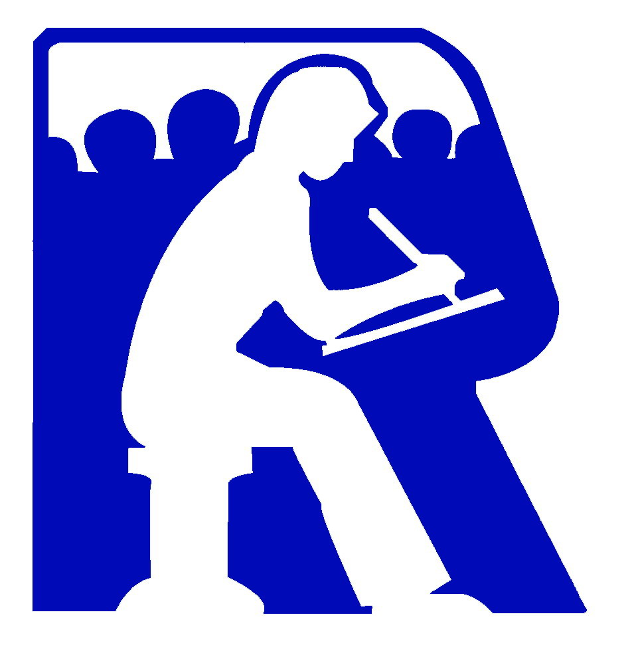

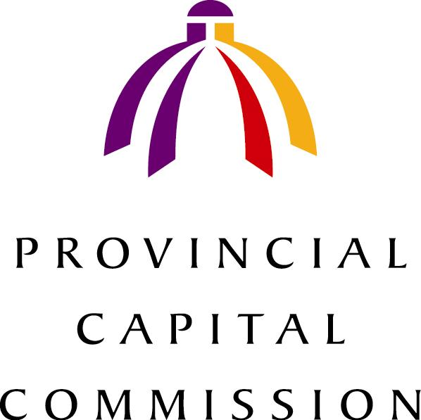
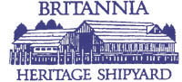
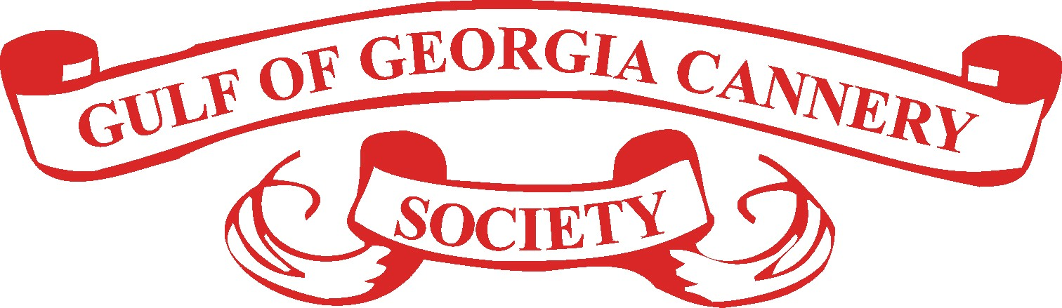
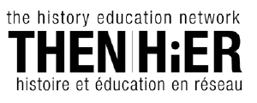


Supported by:
Richmond
School District #38
Richmond
Heritage
Commission

